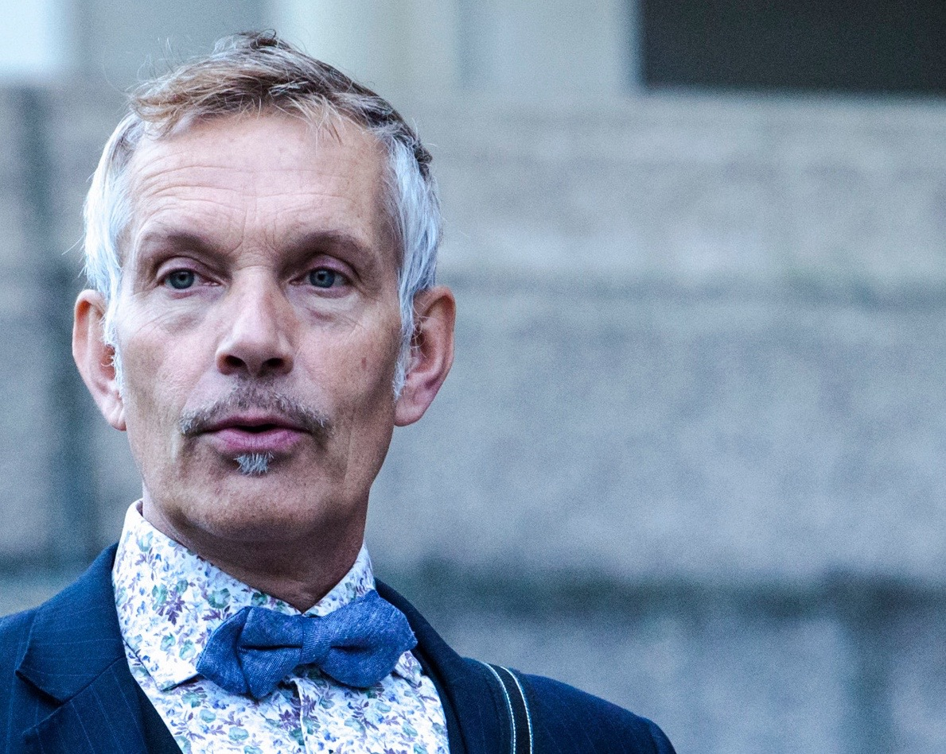 Rinus Sprong CV

Artistic co-director De Dutch Don't Dance Division, De Dutch Summer Dance Course

Rinus Sprong graduated in 1981 from the Rotterdam Dance Academy to join Nederlands Dance Theater ll, in The Hague, under directorship of Jiří Kylián.
Amongst other company’s he danced with are Le Theâtre Choréographique de Rennes, Intro Dans Arnhem, Scapino Ballet and Bat-Dor Dance Company Tel-Aviv. Amongst the choreographers he worked with are Nils Christe, Hans van Manen, Ed Wubbe, Mats Ek, William Forsyth and Armando Navarro.
He worked also for different productions and festivals in The Netherlands and abroad, in contemporary works as well as classical and neo-classical ballets, as well as television like So You Think You Can Dance and Everubody Dance Now. He is responsible for the choreography of D.J. Armin van Buuren's world tour 'Intense' (2014-15) and the new worldtour 'Embrace' (2016-17)
As teacher he has been working for a.o. Rotterdam Dance Academy, Scapino Ballet, ArtEz University of the Arts, the Henny Jurriëns Foundation Amsterdam and Conny Jansen Danst. He got his teachers degree from the university of Amsterdam in 2001.
Together with Thom Stuart he founded De Dutch Don’t Dance Division, initiator of many diverse and different dance/theater projects and productions. In 2005 they founded De Dutch Summer Dance Course, the first and only international dance course in The Netherlands focussing on inclusing all ages in two weeks of dance, the Dutch Dance Heritage and the inspiration from other art forms and social systems.The focus on the technical development of the body, allways in service of the performing art and development of the indiviual dancer towards the promise of his/her own talent.

In 2008 he was awarded Culturalis-Prize of the city of The Hague for his contribution to the culture of al citizens and in 2012 he received the Prize of Merrit of the Dancers Foundation'79.

( se also www.ddddd.nu )

