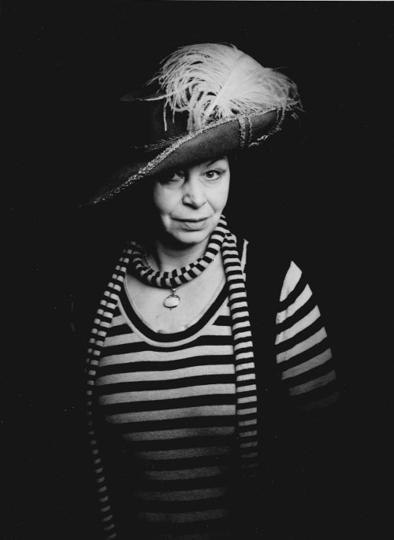 | Olga Kyndlová graduated in classical dance at the Conservatory in Bratislava and dance pedagogy at HAMU in Prague. She danced at the SND in Bratislava, at the State Theater in Ostrava, at the Karlín Music Theater, at the National Theater in Prague and has been a member of the ballet ensemble since the establishment of the Prague State Opera in 1992.
In the years 1998-2000 she taught at the 1st private dance conservatory in Prague. She participated in the establishment of the Ballet School at the Prague State Opera (formerly the SOP Ballet Preparation), which she has been leading since 1995. Since 2000 she has been working as an assistant director at the Prague State Opera, where she had the opportunity to collaborate with many important Czech and foreign directors: Troška - G. Bizet - Carmen (2004), A. Dvořák - Rusalka (2005), J. Nekvasil - E. Viklický - Faidra (2000), A. Zemlinsky -Es war einmal (2000), K. Weiss - Polish Jew (2001), T. Madsen - Circus Terra (2002) J.Massenet - Don Quixote (2010), L. Bělohradská - F. Poulenc - La Voix Humaine (2000 ), K. Štaubertová-Sturm - A. Schönberg - Erwartung (2000), P. Tyc - WA Mozart, G. Gazzaniga - Don Giovanni (2001), J. Gillar - S. Joplin - Treemonisha (2003), M. Tarant - A. Dvořák - Dimitrij (2004), J. Bednárik - G. Puccini - Manon Lascaut (2007), K. Kříž - G. Verdi - I Vespri Siciliani (2006), O. Havelka - G. Puccini - La Bohéme(2008), P. Kracik - F. Lehár, E. Kálman, J. Strauss - Vivat operetta (2009) M. Kukučka and L. Trpišovský - WA Mozart - Don Giovanni (2012). Among the foreign directors with whom she collaborated were, for example, D. Kaegi - A. Thomas - Hamlet (2002), G. Blin - A. Vivaldi - Orlando Furioso (2001), P.-É. Fourny - P. Dukas - Ariane et Barbe-blue (2001), DR Pařízek - E. Viklický - The Plowman and Death (2003), R. Hovenbitzer - R. Leoncavallo - La Bohéme (2003), A. Nekovar - G. Donizetti - Lucia di Lammermoor (2004), S. Taylor - R. Wagner - Der Fliegende Holländer (2008), M. Lombardero - R. Wagner -Tristan and Isolde (2010) - H. Schörghofer - Ch. W. Gluck - Orpheus and Eurydice (2013). In 2006, she collaborated with her colleague L. Cukr on the production of WA Mozart's opera Don Giovanni for the production of the MozArt Opera at the Estates Theater. In 2009 she assisted him with Verdi's Otell and in 2011 with Verdi's Troubadour, both at the Prague State Opera. In 2006, she directed Bizet's Carmen in Seoul, South Korea, for the opera company Beseto , in which Czech and Korean artists participated. At the Opera Week festival in Kutná Hora in 2001, she assisted L. Štros in the preparation of Mozart's Don Giovanni and in 2003 at Bizet's Carmen,where she also collaborated as a choreographer. Together with L. Cukr, she participated in the preparation of Puccini's Tska in 2008, in 2011 she independently directed Puccini's Bohém and in 2012 Verdi's Traviata . For the pupils of the Ballet School, she directed and directed the Children's Christmas Mass by V. Bulíček and M. Podéšťová, which the children have been successfully presenting at various charitable events every year since 1998. In 1996 , she prepared Easter Passions for the Easter holidays with her children , which also have their own annual tradition. She has created countless choreographies for the Ballet School, with which children present themselves at ballet school competitions and also in performances at the end of the school year on the stage of the State Opera.

